# Tutorial 07 Learning Objectives

Drupal 8 concepts and terminology

The benefits of using Drupal and how it compares to other systems

The process of creating a new Drupal 8 website

Drupal core functionality and how to use contributed modules

Confidence to dive deeper into Drupal 8

Using menus to structure your site

Managing users and permissions

Installing and configuring contributed modules

Creating layouts with blocks

**Tutorial 07 Parts Index:**

Part A - Student information

Part B - Building Drupal 8 sites on all platforms

Part C - The Drupal 8 Administration Toolbars and Menu Review

Part D - Extending Drupal through Themes (Page 8)  
Part E - Introduction to Adding Site Content – Basic page (Page 24)  
Part F - Drupal 8 Menu Management   
Part G - Introduction to Adding Site Content – Articles

Part H - Hardening a Drupal 8 site – Prevent unwanted new account solicitations

Tutorial 07 D2L – 2 Assets:  
(1) Tutorial 07 Assets.zip

(2) ca-drupal8.y.z-basic-builder.sh 🡨 Linux BASH script

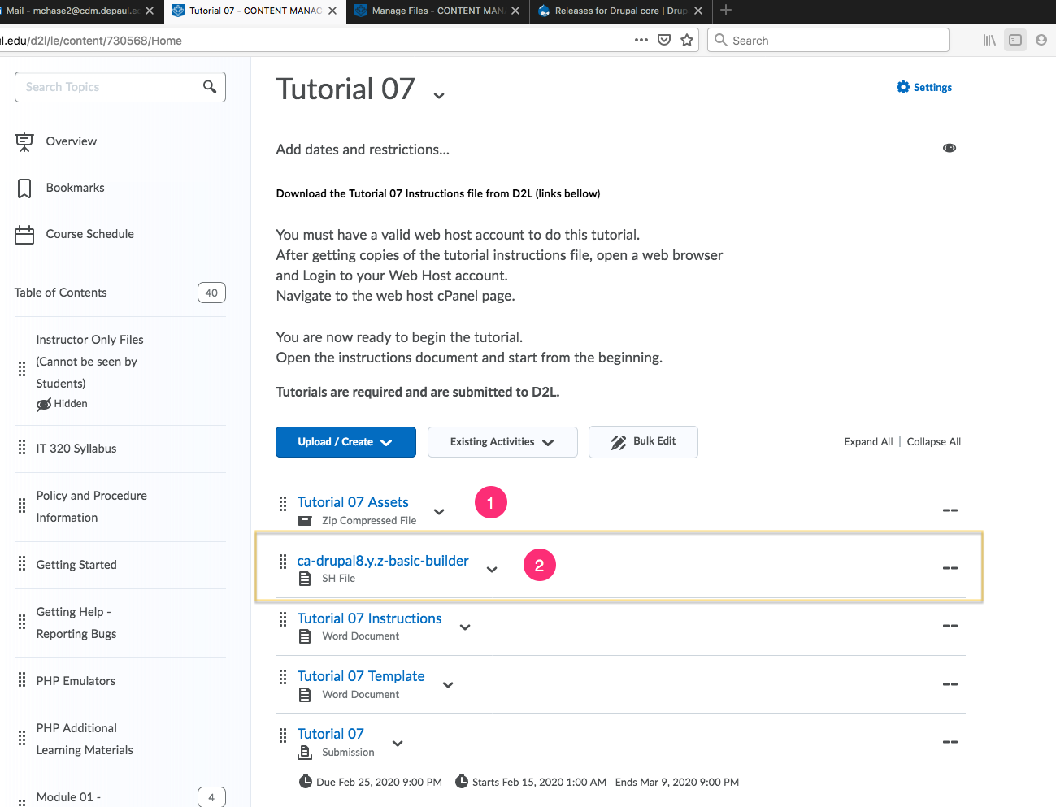

Tutorial 07 Folder and File Assets: “Tutorial 07 Assets.zip”

|  |
| --- |
| HD:private:var:folders:vh:lbh1qypx7zldldk1l9f6tpsc0000gn:T:2020-01-02_18-40-42.png |

Part A – Student information

1. Download and save a copy of the Tutorial 07 Template document
2. Rename the template document   
   **[Your-Name or Initials]-**Tutorial-07-Template.docx
3. Go to the template and enter student information in Part A.

Part B – Building Drupal 8 sites on web hosts

Follow along as we review building Drupal 8 sites on shared web hosts and Cloud development environments.

1. Building Drupal 8 sites on shared web hosts with one click cPanel install
   1. **Version:** Select the default (most recent Drupal 8 version)
   2. **In Directory:** tutorial07
   3. CRON Job: Keep default values (do not change)
   4. Site Settings:
      1. Site Name –[Your First Name] – Drupal 8 – Tutorial 7
   5. Admin Account
      1. **Admin Username:** <create your own username>
      2. **Admin Password:** <enter a string password & write it down>
      3. **Admin Email**: Use the default email
   6. Advanced Options
      1. **Database Name:** keep default – write it down
      2. **Table Prefix:** keep default – write it down
      3. **Backup Location:** keep default
2. Building Drupal 8 sites on Pantheon (PaaS) – For those with Pantheon accounts
   1. **Create Your Pantheon Site:**
      1. **Name Your Pantheon Site:** [Your Initials] - Tutorial 07
      2. **Choose an Organization:** None
      3. **Choose a Region for the Site:** United States
   2. Choose Your CMS:
      1. Select Deploy for Drupal 8
   3. Drupal 8 Site Configuration settings:
      1. Choose language: English
      2. Select an installation Profile: Standard
      3. Configure Site:
         1. Site Name: <Your Initials> - Tutorial 07 – D8
         2. Site Email address: <your Pantheon account email>
         3. Username: enter a username
         4. Password: enter a string password – write it down
         5. Email address: use your Pantheon account email
         6. REGION Settings:
            1. Default Country: United States
            2. Default Time Zone: Chicago
            3. UPDATE Notification:

Check for updates automatically – CHECKED

Receive email notification: CHECKED

1. Building Drupal 8 sites on the cloud - Codeanywhere Drupal 8 build script
   1. Drupal 8 Build Script: ca-drupal8.y.z-basic-builder.sh

Codeanywhere Drupal 8 Build Script Instructions:

1. Open a web browser and navigate to Drupal.org - get the latest Druapl 8.y.z CORE version number
2. Logon to your Codeanywhere account
3. Create a new connection of type PHP - PHP Development stack with Apache, PHP, MySQL, phpMyAdmin and Composer pre-installed
   1. We are using a shared Codeanywhere space - prepend your initials to the connection name
4. On the container info TAB
   1. Record the root username on the first line [root user without password]
5. From the container info page, select and access and log int phpMyAdmin on another TAB
6. Login to phpMyAdmin as root user name and no password
7. Select Databases
8. Create a database named drupalxyz# - where xyz are your initials and number is a single digit number
   1. We are using a shared Codeanywhere account, so the database name must contain your initials to make it unique
9. Back on the Codeanywhere dashboard, upload this script file to the workspace
10. Open the bash command window and run the following BASH command to make the script executable
    1. [your-name:/~workspace $] chmod +x ca-drupal8.y.z-basic-builder.sh
11. In the BASH command window run this script
    1. [your-name:/~workspace $] ./ca-drupal8.y.z-basic-builder.sh 8.8.0
    2. the script will download the Drupal 8.y.z core files and establish folders for running the Drupal 8 install script
12. In another TAB Enter the URL of the application over HTTPS - this will start the Drupal 8 site building script
13. Fill out the required fields and build your Drupal 8 site
    1. Use a short all lowercase UNIQUE Drupal 8 site name - using your initials
    2. The Database (DB) is what you named it in step 8
    3. Always set the country and city & check both the update checkboxes
14. This script copies the example.settings.local.php to create the settings.local.php in the sites/default folders
15. When the build script completes, press the 'Visit your new site link' and record the URL of this site

Go to the Tutorial 07 Template and take and record the requested screen captures and site login credentials for your Drupal 8 CMS sites for Part B.  
  
**Part C – The Drupal 8 Administration Toolbars and Menu Review**

* Open a web browser and navigate to your Drupal site.
* You are now looking at your Drupal 8 site’s client facing front end as an anonymous user.
* Let’s login to your site and review the site administration toolbars and menus from top to bottom.

|  |
| --- |
| * 1. Select (click) the Log in link (upper right corner) |
| HD:private:var:folders:vh:lbh1qypx7zldldk1l9f6tpsc0000gn:T:2017-03-26_15-11-27.png |
| * 1. Enter username and password   2. Select (click) the “Log in” button |
| HD:private:var:folders:vh:lbh1qypx7zldldk1l9f6tpsc0000gn:T:2017-03-26_15-12-08.png |

|  |  |
| --- | --- |
| * 1. Admin Menus and Tool bars      1. the Administrative menu – starts with Manage      2. the Administrative submenu bar – starts with Content      3. the User account menu – My account & Log out      4. the Main navigation menu – starts with Home      5. the Tools menu (left column) – stars with Add content      6. the Footer menu – starts with Contact | |
| HD:private:var:folders:vh:lbh1qypx7zldldk1l9f6tpsc0000gn:T:cc.png | |
| Clicking Manage – Enables and disabled the Administrative submenu bar | |
| HD:private:var:folders:vh:lbh1qypx7zldldk1l9f6tpsc0000gn:T:2017-03-26_16-19-19.png | HD:private:var:folders:vh:lbh1qypx7zldldk1l9f6tpsc0000gn:T:2017-03-26_16-18-49.png |

|  |
| --- |
| \* Shortcuts – Is a dynamic menu – You can add, edit, and delete shortcut links (1) Add content – create site content using content type templates  (2) All content – list all site content, Filter by content type, change node states  (3) Edit shortcuts – Edit the shortcuts links  (4) Toggle – Horizontal to vertical menu display |
| HD:private:var:folders:vh:lbh1qypx7zldldk1l9f6tpsc0000gn:T:2017-03-26_16-21-46.png |
| **User account link** – the link is your user name (1) My account – appears to be the same as selecting the user name link  (2) Log out – log off the site  (3) View – Membership time  (4) Shortcuts (Advanced – Not covered)  (5) Edit – Change your account information – Email, username, password, role |
| HD:private:var:folders:vh:lbh1qypx7zldldk1l9f6tpsc0000gn:T:2017-03-26_16-25-56.png |

|  |
| --- |
| Toggle Administrative submenu bar Horizontal to Vertical display  (A) To toggle from Horizontal to Vertical |
| HD:private:var:folders:vh:lbh1qypx7zldldk1l9f6tpsc0000gn:T:2017-03-26_16-31-56.png |
| (B) To toggle from Vertical back to Horizontal |
| HD:private:var:folders:vh:lbh1qypx7zldldk1l9f6tpsc0000gn:T:2017-03-26_16-32-12.png |

|  |
| --- |
| Administrative submenu bar |
| HD:private:var:folders:vh:lbh1qypx7zldldk1l9f6tpsc0000gn:T:2017-03-26_16-35-37.png |
| See Above: (1) Content:  List site content, comments and files.   Filter search  Change content states.  (2) Structure:  Edit exisitng content type templates (Basic page & Article)  Create new content type templates  Create views – node aggragate page displays |
| (3) Appearance:  Install new themes  Enable and set default client facing themes  Enable Site Administraiton themes  Edit cleint facing theme settings  (4) Extend  Extend Drupal by adding new modules to your site  Enable and disable moduels  Update and Uninstall modules  Link access to module Help, Permission and configuraiton pages (if supported) |
| (5) Configuration  Access to sections of links to configuation settings pages  This is dyanmic and cheges as you add modules  (6) People  Add new users  Enable and disable user accounts  Permission modules – defines which roles can access modules  Edit exisitng role privileges  Add new roles |
| (7) Reports – Access to report links (Status report) |
| (8) Help – List of all the help pages. This is dynamic and chages as you ass modules |
|  |

## There are no questions to answer or screen captures for Part C.

## Part D - Extending Drupal through Themes

What is a theme?

* Themes change the look and feel of the client facing Drupal website.
* A theme is a collection of files of various extensions that define the presentation layer.
* You can also create one or more "sub-themes" or variations on a theme.
* Drupal 8 themes are defined with an [.info.yml] file.
* Twig is the default template engine for Drupal 8.
* Themes contain defined regions, where we can position content blocks.

### Be Careful when installing Drupal 8 Front End Themes

Many of these themes do not work very well and may have issues with menu and content display.  
The reason for these issues is that Drupal 8 is not an extension of Drupal 7.   
Drupal 8 it is a complete re-write. Drupal 7 was coded using procedural PHP. Drupal 8 (core and modules) are coded completely with object oriented PHP. Additionally, Drupal 8 utilizes the composer package manager and TWIG. The themes in Drupal 8 are completely different. Drupal7 themes were written in procedural PHP and CSS and have PHP configuration files. Drupal 8 themes are written in TWIG, are object oriented and use XAML configuration files. Some Theme companies list their Drupal 8 theme as being Drupal 8 compatible, but they are not coded with TWIG and are not object-oriented themes. These themes do not work very well. So be aware and be prepared. Test your themes on test site before showing them to a client or using them on a production or development site.

**Always research on your Drupal 8 theme before installing it. And always have a backup on your web host that you can use to recover from a catastrophic event.**

Try to only select and use secure and well-maintained Drupal 8 themes.   
Try not to use themes with security issues, also know as vulnerabilities.  
Example Nexus theme 2019 (see image below):

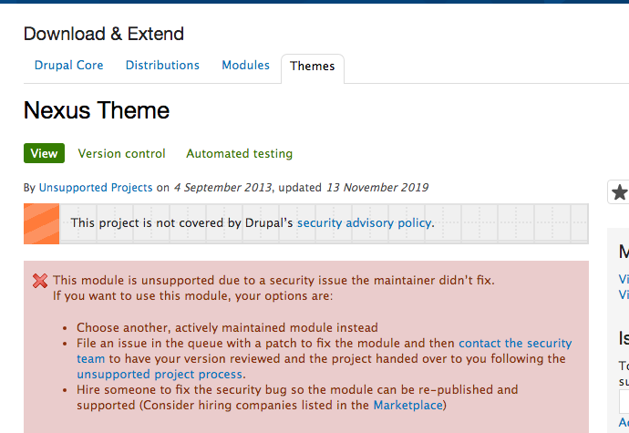

Drupal has Two Types of Themes – Admin and Front End Client Facing:

There are two types of Drupal themes. Front-end Client-Facing and Administrative themes. These two themes are different types of themes and should not be used interchangeably.

Do not set an Administrative theme as a default Front-end theme.  
Do not set a front-end theme as the site Administrative theme.

Setting the Administrative theme is done on the Appearance page, at the bottom, in the ADMINSTRATION THEME section.   
Seven is the name of the default Drupal 8 Administrative theme.  
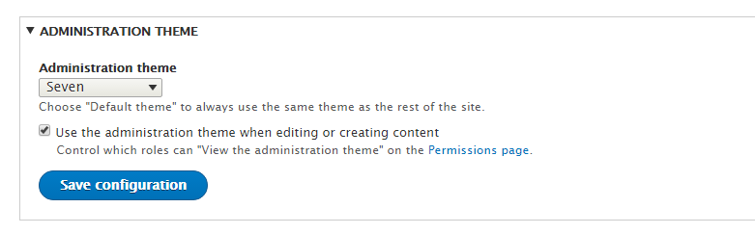

To change the Administration theme, select the Administration Theme select control and select the theme.

There is an issue with Administration Theme select control.   
It lists all the themes, front-end client facing and backend Administration themes.

This is an instance of Drupal allowing you to mess up your site, by not properly filtering the contents of the select control.   
Please look at the image below.   
In my opinion - the Bartik theme should not be listed, as it’s not an Administration theme.

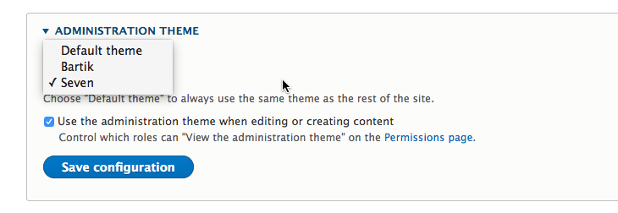

When searching for a Drupal 8 Administration Theme replacement, make sure it has Drupal Core Compatibility of 8.x and is an actual Administration theme.   
A good way to identify an Administration theme is that they usually have the Word Administration or Admin in their theme name.  
  
Examples:

|  |
| --- |
| HD:private:var:folders:vh:lbh1qypx7zldldk1l9f6tpsc0000gn:T:2020-01-04_09-39-59.png |
| HD:private:var:folders:vh:lbh1qypx7zldldk1l9f6tpsc0000gn:T:2020-01-04_09-41-34.png |
| HD:private:var:folders:vh:lbh1qypx7zldldk1l9f6tpsc0000gn:T:2020-01-04_09-43-08.png |

To implement and install an Admin theme to your Drupal 8 site

1. Research admin themes and find one that fits your feature list
2. Open a web browser, navigate to the Admin Themes Project page  
   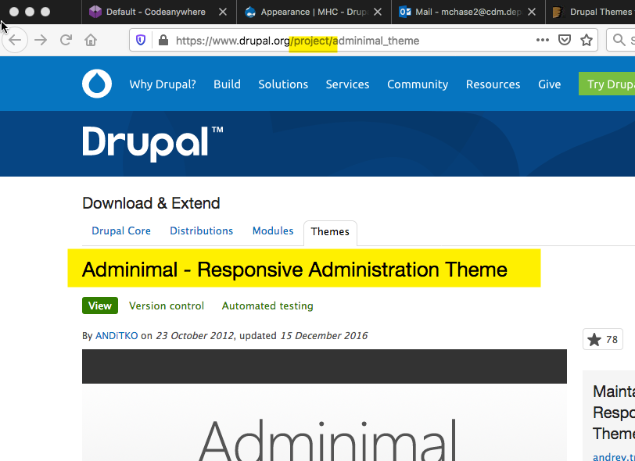
3. Scroll down to the Downloads section

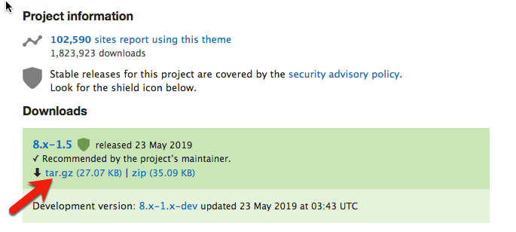

1. Copy the 8.x compressed file Link location

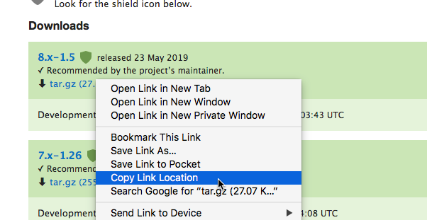

1. On the Drupal 8 backend, access the Appearance page
2. Select +Install new theme
3. Paste the compressed file link path into the “install from URL” edit box  
   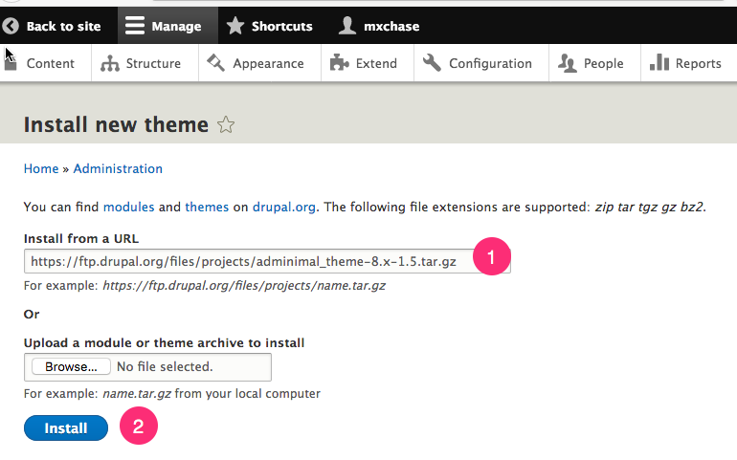
4. Verify the theme URL – make sure its for the correct theme
5. Press the Install button (see image above)
6. Select the link to install newly added themes  
   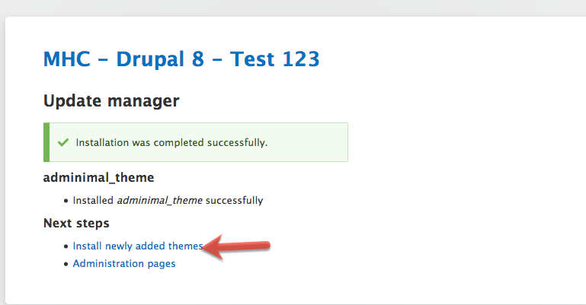
7. On the Appearance page, locate the newly installed theme in the Uninstalled themes section
8. Select the Install link –DO NOT SELECT Install and set as Default
   1. The install and set as Default is reserved for front end client facing themes, not Administration themes  
      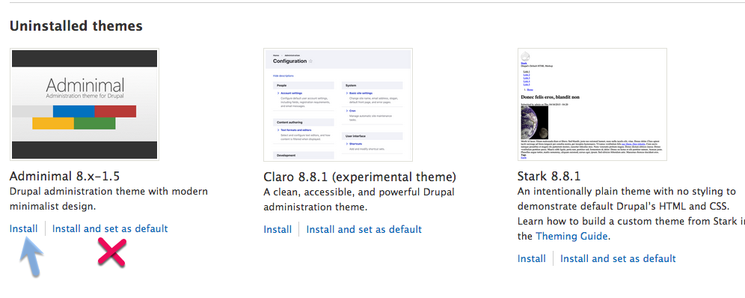
9. Select the Administration theme from the select list control
10. Press the Save configuration button

Front-end Client Facing Themes

The Default Front-end theme:  
The Default front-end Client facing themes are identified on the Appearance page with the text   
(default theme), to the right of the theme name.  
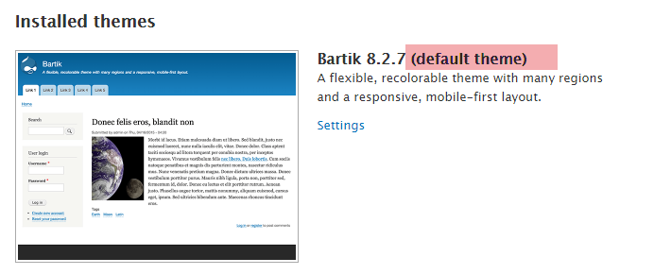

ADDING THEMES to the site:

New themes are added to the system as **uninstalled**.  
Uninstalled themes are listed toward the bottom of the Appearance page, in the Uninstalled themes section.  
Setting the client-facing front-end theme is done within the Appearance page.  
Front-end client facing themes can be Installed and set as default by selecting the   
“**Install and set as default**” link.   
Once installed and set as default is clicked, the theme is set as the Drupal site’s default theme.

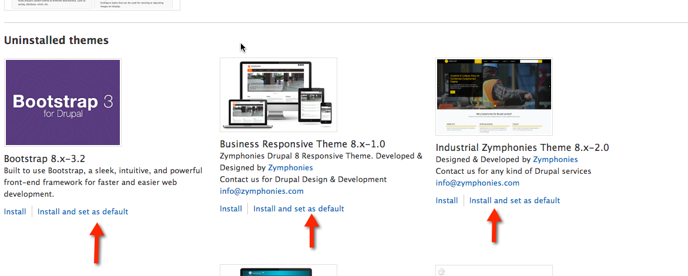Installing front-end client facing and site administration themes

First front-end theme: **Drupal8 Zymphonies Theme**  
Theme Project Page URL: https://www.drupal.org/project/drupal8\_zymphonies\_theme

Installing Client-Facing Front End Themes & Setting the default

|  |
| --- |
| 1. Open a web browser and navigate to the theme project page https://www.drupal.org/project/drupal8\_zymphonies\_theme |
| HD:private:var:folders:vh:lbh1qypx7zldldk1l9f6tpsc0000gn:T:2018-11-12_11-36-53.png |
| 1. Scroll down to the Downloads section |
| 1. Select & copy the correct download file path **Copy link address** |
| HD:private:var:folders:vh:lbh1qypx7zldldk1l9f6tpsc0000gn:T:2018-11-12_11-38-59.png |
| 1. On the Drupal site, select Appearance > Install a new theme |
| HD:private:var:folders:vh:lbh1qypx7zldldk1l9f6tpsc0000gn:T:2018-11-12_11-42-17.png |
| On the Install a new theme page: (A) Paste the download file path into the “Install from a URL” text box  - Verify that the theme is  (B) Press the “Install” button |
| HD:private:var:folders:vh:lbh1qypx7zldldk1l9f6tpsc0000gn:T:2017-03-28_13-41-17.png |

|  |
| --- |
| Upon completion of the install, the success message displays. (A) Select the **Install newly added themes** link to go to the **Appearance** page |
| HD:private:var:folders:vh:lbh1qypx7zldldk1l9f6tpsc0000gn:T:2018-11-12_11-43-07.png |
| On the Appearance page, scroll down to the Unistalled themes section and select the “install and set as default” link |
| HD:private:var:folders:vh:lbh1qypx7zldldk1l9f6tpsc0000gn:T:2018-11-12_11-44-34.png |

|  |
| --- |
| The selected theme is now at the top of the Appearance page and is listed as the default theme |
| HD:private:var:folders:vh:lbh1qypx7zldldk1l9f6tpsc0000gn:T:2017-03-28_13-43-08.png |

## Configuring the default Client-Facing Front End Theme

**To set the default theme settings:**

|  |
| --- |
| Open the Appearance page |
| Select the settings link for the default theme |
| **HD:private:var:folders:vh:lbh1qypx7zldldk1l9f6tpsc0000gn:T:2017-03-28_13-43-08.png** |
| **Review Page Elements** |
| **HD:private:var:folders:vh:lbh1qypx7zldldk1l9f6tpsc0000gn:T:2017-03-28_13-46-09.png** |

|  |
| --- |
| **Review social media link settings** |
| **C:\Users\mchase2\Desktop\aaX1\s2.png** |
| **Turn off Social media link settings** |
| * + - * 1. **Un-check Show social icons**         2. **Select “Save configuration”** |
| **HD:private:var:folders:vh:lbh1qypx7zldldk1l9f6tpsc0000gn:T:2018-11-12_11-46-55.png** |

### How to search for Drupal 8 themes on Drupal.org

|  |
| --- |
| **1. Open a web browser and navigate to Drupal.org** |
| **HD:private:var:folders:vh:lbh1qypx7zldldk1l9f6tpsc0000gn:T:2017-03-28_13-50-23.png** |
| **2. Scroll to the bottom footer and select Themes** |
| **HD:private:var:folders:vh:lbh1qypx7zldldk1l9f6tpsc0000gn:T:2017-03-28_13-50-11.png** |

|  |
| --- |
| Restrict your search to only Drupal 8 themes, by setting Core compatibility to 8.x |
| **HD:private:var:folders:vh:lbh1qypx7zldldk1l9f6tpsc0000gn:T:2017-03-28_13-51-05.png** |

|  |
| --- |
| Scroll down and find **Nexus** Theme |
| **HD:private:var:folders:vh:lbh1qypx7zldldk1l9f6tpsc0000gn:T:2017-03-28_13-51-37.png** |

|  |
| --- |
| **Select the Theme image to navigate to the Theme Project page.**  **Once there, copy the correct download file path and install the Theme and make it your site’s default theme** |
| **HD:private:var:folders:vh:lbh1qypx7zldldk1l9f6tpsc0000gn:T:2020-01-03_09-57-13.png** |

|  |
| --- |
| **Scrol down and find the version 8.x release and copy link address** |
| **HD:private:var:folders:vh:lbh1qypx7zldldk1l9f6tpsc0000gn:T:2020-01-03_09-58-24.png** |
| **Go Back to the Appearcene page and install the theme** |
| **HD:private:var:folders:vh:lbh1qypx7zldldk1l9f6tpsc0000gn:T:2018-11-12_11-54-23.png** |
|  |
| **HD:private:var:folders:vh:lbh1qypx7zldldk1l9f6tpsc0000gn:T:2020-01-03_10-00-29.png** |
| **Select Install newly added themes** |
| **HD:private:var:folders:vh:lbh1qypx7zldldk1l9f6tpsc0000gn:T:2018-11-12_11-54-44.png** |

|  |
| --- |
| **Select Install and set as default** |
| **HD:private:var:folders:vh:lbh1qypx7zldldk1l9f6tpsc0000gn:T:2020-01-03_10-01-19.png** |
| **New Theme is now the default client-facing theme** |
| **HD:private:var:folders:vh:lbh1qypx7zldldk1l9f6tpsc0000gn:T:2020-01-03_10-44-45.png** |

|  |
| --- |
| **Select “Back to site” (see above – to see the theme on the site)** |
| **HD:private:var:folders:vh:lbh1qypx7zldldk1l9f6tpsc0000gn:T:2020-01-03_10-45-21.png** |

### 

Part D Exercises:

1. Open a web browser and navigate to Drupal.org
2. Go to the bottom of the page and select Themes (under Download & Extend)
3. Change the Core compatibility to 8.x and Search for Thunder Admin and Creative Responsive theme   
   Or use the following Thunder Admin Theme project page URL  
     
   Project URL: <https://www.drupal.org/project/thunder_admin>
4. Install the Thunder Admin theme and set it as the ADMINISTRATIVE THEME
5. Install the Drupal 8 Creative Responsive theme as the default client facing front end theme

Project URL: <https://www.drupal.org/project/creative_responsive_theme>

1. Install the Go to the Tutorial 07 Template and answer the questions and take screen captures for Part D.

Part E - Introduction to Adding Site Content – Basic page

1. Introduction to CMS Content types   
   *Drupal comes with 2 content types enabled by default,* ***Basic page*** *and* ***Article****.  
   Basic page and Article have different structures and purpose.  
   Basic pages are typically used for static content and have links on a menu.   
   Basic pages do not have an image by default.*

*Articles are for timely content, not statics, and are typically displayed on the front page, and do not have a menu item link. Article also have a taxonomy-vocabulary file, named Tag and an image field by default.  
Both of these content types have a structure that is at its core a template form. When you create content, you fill out the template form of that particular content type, configuring it to your specifications. The template has a WYSIWYG toolbar, so you can edit content without coding, and without having to use special programming languages. When you save your “page”, it is published to your site and is immediately visible to all.*

1. Content type Basic Page named “About me “

|  |
| --- |
| Access the Add content page:   * 1. **Administrative menu bar** > Content, + Add content   - OR -  b. \* Shortcuts > Add content |
| **Administrative menu bar** > Content, + Add content |
| **HD:private:var:folders:vh:lbh1qypx7zldldk1l9f6tpsc0000gn:T:2020-01-03_10-16-07.png** |
| \* Shortcuts > Add content |
| **HD:private:var:folders:vh:lbh1qypx7zldldk1l9f6tpsc0000gn:T:2020-01-03_10-17-08.png** |

|  |
| --- |
| To Add a Basic page NODE On the Add content page - Select the Basic page link |
| HD:private:var:folders:vh:lbh1qypx7zldldk1l9f6tpsc0000gn:T:2020-01-03_10-22-57.png |
| Fill out the Basic page template and Save and Publish to post the page to the site Red stars ( **\*** ) indicate required fields   1. Title – The title of your page 2. The WYSIWYG toolbar 3. The Body =where you enter the page content 4. The HTML settings of the body display – Keep it at Basic for now 5. Publish check box 6. The Revision log message – I use this! 7. The Menu settings – You have to open it up to set it 8. The Promotion settings – We do not want our new page on the home page, so we will not select any items in this settings section. |
| HD:private:var:folders:vh:lbh1qypx7zldldk1l9f6tpsc0000gn:T:2020-01-03_10-23-49.png |
| Basic Page Content Title: About me |
| Body:  My name is Michael Chase I am a trained clinical Microbiologist. I have worked and performed research in healthcare and food science. I was retrained as a programmer analyst in the 1980s at DePaul University.  LINK: <https://www.depaul.edu/Pages/default.aspx> |
| Below I have entered the Title and some body content. Additionally I have used the WYSIWYG to create a LINK to DePaul |
| HD:private:var:folders:vh:lbh1qypx7zldldk1l9f6tpsc0000gn:T:2020-01-03_10-30-25.png |

|  |  |
| --- | --- |
| Now I have used the WYSIWYG to Bold my name and create a numbered list. (3) Notice **Published** (check box) exists below the Body | |
| HD:private:var:folders:vh:lbh1qypx7zldldk1l9f6tpsc0000gn:T:2020-01-03_10-29-12.png | |
| Below I have added a comment to the Revision log. | |
| HD:private:var:folders:vh:lbh1qypx7zldldk1l9f6tpsc0000gn:T:2017-03-26_17-44-42.png | |
| Below I have opened the **MENU SETTING** block and after selected (checking) the  **Provide a menu link option**, I entered the **Menu link title**, a **Description**, and assigned the menu link to the **<Main navigation>** (MAIN MENU) and gave the menu item a **Weight** of **5**, so it appears to the right of the HOME link. Weights < 1 🡪 Appear to the left (Horizontal) and above Vertical Weight > 1 🡪 Appear to the left (Horizontal) and above Vertical | |
| HD:private:var:folders:vh:lbh1qypx7zldldk1l9f6tpsc0000gn:T:2017-03-26_17-43-53.png | HD:private:var:folders:vh:lbh1qypx7zldldk1l9f6tpsc0000gn:T:2017-03-26_17-44-25.png |

|  |
| --- |
| I opened the PROMOTION OPTIONS  I only want this page to appear when its menu link is selected. Therefore, I will not select (check) **Promoted to the front page** or **Sticky on top of lists** |
| HD:private:var:folders:vh:lbh1qypx7zldldk1l9f6tpsc0000gn:T:2017-03-26_17-44-53.png |
| We have completed configuring out Basic page and we can now save and publish it to the site by selecting the “Save and publish” button |
| HD:private:var:folders:vh:lbh1qypx7zldldk1l9f6tpsc0000gn:T:2020-01-03_10-33-21.png |

|  |
| --- |
| Once you click the “**Save and publish**” Drupal dispalys the page on the site with a success message.  You should now open a different WEB browser, navigate to your site and without loggin in,verify that the “About me” page menu item exists, and slecting it brings you to the page.  **NOTICE: I have moved back to Bartik theme** as the default cleint facing front end theme |
| HD:private:var:folders:vh:lbh1qypx7zldldk1l9f6tpsc0000gn:T:2017-03-26_17-46-04.png |
| Demo Selecting the Edit tab – make a change and save – **Revision tab displays**  **The Revison tab only dispalys after you have enetered 2 revision notes. Until then you will not see the tab on the page** |
| HD:private:var:folders:vh:lbh1qypx7zldldk1l9f6tpsc0000gn:T:2017-03-26_18-19-16.png |
| Demo selecting Delete tab |
| HD:private:var:folders:vh:lbh1qypx7zldldk1l9f6tpsc0000gn:T:2017-03-26_18-10-25.png |

Part E – Exercises   
  
Create two (2) Basic page nodes with the following specifications:

**Titles:** “BP Test 1” and “BP Test 2”

**Body Content: 1** IPSUM paragraph

|  |
| --- |
| Retro VHS 90's fanny pack put a bird on it typewriter. You probably haven't heard of them affogato heirloom echo park microdosing hot chicken banh mi. IPhone ramps synth pug keffiyeh forage scenester portland. Quinoa copper mug echo park tumblr venmo messenger bag vape selvage hexagon readymade. Normcore bicycle rights hot chicken, jianbing affogato gentrify polaroid selfies roof party. |

**Published: checked  
  
Revision Log:** Created the page**.**

**Menu Settings:**

**Provide a menu link: checked   
 Menu link title:** (default) Page title

Description: (use page title)  
 **Parent item:** <Main navigation> **Weight: 10 (for both)**

**URL PATH SETTINGS:** keep default settings **AUTHOR INFORMAITON:** keep default settings **PROMOTION OPTIONS:**

**Promoted to front page:** keep default setting (unchecked) **Sticky at top of lists:** keep default settings (unchecked)

|  |
| --- |
| **HD:private:var:folders:vh:lbh1qypx7zldldk1l9f6tpsc0000gn:T:2020-01-03_10-39-28.png** |

|  |
| --- |
| **After Creating the new Basic page node:** |
| **HD:private:var:folders:vh:lbh1qypx7zldldk1l9f6tpsc0000gn:T:2020-01-03_10-41-49.png** |

|  |
| --- |
| NOTE about Thunder Admin theme:  Increase your web browser page width to see the entire Basic page edit template or press the COG icon  (see image below).  If the screen width is to narrow, the right side block (Published, menu Settings, URL Alias, Authoring Information, and Promotion Options) is hidden. |
| HD:private:var:folders:vh:lbh1qypx7zldldk1l9f6tpsc0000gn:T:2020-01-03_11-14-06.png |
| HD:private:var:folders:vh:lbh1qypx7zldldk1l9f6tpsc0000gn:T:2020-01-03_11-14-55.png |

Go to the Tutorial 07 Template and answer the questions and take and post screen captures for Part E.

## Part F - Introduction to Drupal 8 Menu Management

Menus can be created when content nodes are created. Menus can also be created and managed from the Menu manager.

|  |
| --- |
| **Access the Menu page** Administrative submenu bar > Structure > Menus |
| **HD:private:var:folders:vh:lbh1qypx7zldldk1l9f6tpsc0000gn:T:2017-03-28_08-27-49.png** |
| **Edit the Main navigation menu** Select the Edit menu link for the Main navigation menu |
| **HD:private:var:folders:vh:lbh1qypx7zldldk1l9f6tpsc0000gn:T:2017-03-28_08-28-10.png**   1. **Select the cross-hair to drag and re-order (up and down) menu items**   *You can also drag the menu item right and left to create child (sub-menu) items.  Make sure your theme supports child menu items. Our current them Bartik does not support child menu items*   1. **Check and uncheck to enable and disable menus** 2. **Select dropdown control to edit the menu item name and delete a menu item** 3. **Press the Save button to save your changes** |
| **HD:private:var:folders:vh:lbh1qypx7zldldk1l9f6tpsc0000gn:T:2018-11-12_12-25-43.png** |

|  |
| --- |
| **After moving “BP Test 2” above BP Test 2”**  **Press the Save button to save your changes** |
| **HD:private:var:folders:vh:lbh1qypx7zldldk1l9f6tpsc0000gn:T:2018-11-12_12-26-40.png** |
|  |

5.1 Editing Menu Items on Menu Manager*I want to make sure I mention child menu items.   
As we move toward CMS mobile compatibility, we move toward a more flat menu architecture. In other words, less child menus.   
However, if you are designing a CMS website with child menus, then please remember, if you want the child menus items to display when you mouse over the parent menu item, you must check (set) the parent menu item’s “Show as expanded” setting.*

|  |
| --- |
| **1. Select Edit** |
| **HD:private:var:folders:vh:lbh1qypx7zldldk1l9f6tpsc0000gn:T:2017-03-28_13-03-28.png** |
| 1. **Check Show as expanded** 2. **Press the Save button** |
| **HD:private:var:folders:vh:lbh1qypx7zldldk1l9f6tpsc0000gn:T:2017-03-28_13-02-12.png** |
|  |

**5.2** Create a Main Menu Link from the Menu Manager

### Exercise 5.2: Create one (1) Basic page nodes without a menu setting

Create one (1) Basic page nodes:   
**Title:** **BP Test 3**

**Body Content: 1** IPSUM paragraph

|  |
| --- |
| Lorem ipsum dolor amet jean shorts palo santo chia artisan asymmetrical synth pop-up butcher post-ironic tote bag direct trade. Authentic sustainable irony XOXO lumbersexual photo booth iPhone lomo echo park trust fund godard. 3 wolf moon swag pop-up, kickstarter pickled kale chips post-ironic. Truffaut vape tacos air plant thundercats edison bulb, retro pinterest hammock. |

**Revision Log: Created the page.**

**Menu Settings:**

**Provide a menu link:** unchecked

**URL ALIAS SETTINGS: /bp-test-3**

|  |
| --- |
| **HD:private:var:folders:vh:lbh1qypx7zldldk1l9f6tpsc0000gn:T:2020-01-04_10-13-50.png** |

Create a new main menu option for Pasic Page node “BP Test 3”, with URL alias “/bp-test-3”

|  |
| --- |
| **Access the Menu page** Administrative submenu bar > Structure > Menus |
| **HD:private:var:folders:vh:lbh1qypx7zldldk1l9f6tpsc0000gn:T:2017-03-28_08-27-49.png** |
| **Edit the Main navigation menu** Select the Edit menu link for the Main navigation menu |
| **HD:private:var:folders:vh:lbh1qypx7zldldk1l9f6tpsc0000gn:T:2017-03-28_08-28-10.png** |

|  |
| --- |
| **Select “+Add link”** |
| **HD:private:var:folders:vh:lbh1qypx7zldldk1l9f6tpsc0000gn:T:2018-11-12_12-33-02.png** |

|  |
| --- |
| **Fill out the “Add menu link” form  (2) Link – use the URL alias preceded by a “/” (&) Weight = 10, sits to the right of the Home link** |
| **HD:private:var:folders:vh:lbh1qypx7zldldk1l9f6tpsc0000gn:T:2020-01-04_10-18-00.png** |

|  |
| --- |
| **Select “< Back to site” and test the new Main menu item** |
| **HD:private:var:folders:vh:lbh1qypx7zldldk1l9f6tpsc0000gn:T:2018-11-12_12-36-02.png** |
| **The new menu item exists** |
| **HD:private:var:folders:vh:lbh1qypx7zldldk1l9f6tpsc0000gn:T:2020-01-04_10-31-20.png** |
|  |

# 

# Part F Exercises

Make sure Bartik is the default front-end client-facing theme

The current Drupal 8 site main navigation menu should look like this picture below:  
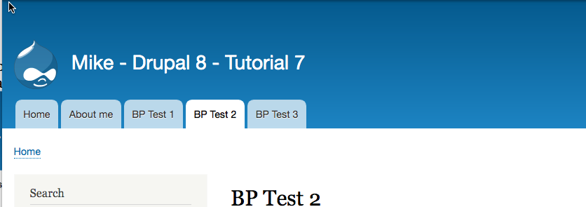

# Re-order the main navigation menu so it appears like the picture below: HD:private:var:folders:vh:lbh1qypx7zldldk1l9f6tpsc0000gn:T:2020-01-11_17-34-34.png

# Go to the Tutorial 07 Template and follow and take screen captures for Part F

# Part G - Creating Article Node Content (Codeanyhwere)

Switch over and start using your Codeanywhere Drupal 8 site.

Articles have a **Picture** and **Tag fields** by default.  
The Tag field is a reference to a Taxonomy vocabulary named **Tags**.  
Taxonomies give your sites use of organizational keywords, known in other systems as categories, tags, or metadata. They allow you to connect, relate and classify your website’s content. In Drupal, these terms are gathered within "vocabularies". The Taxonomy module allows you to create, manage and apply those vocabularies.

Access your Codeanywhere Drupal 8 site and follow along as we create Article node content about deserts

1. Assets zip file: Tutorial 07 Assets.zip
2. Extracted Assets Zip folder: CMS Front Page Articles
3. Extracted CMS Front Page Article Folder file:
   1. **File: Deserts.txt** – open in an ASCII editor
4. Create the first desert Article with Title: **Brownie Directions**

|  |
| --- |
| Access the Add content page:   1. **Administrative submenu bar** > Content, + Add content   Or  B. **Administrative menu** > Shortcuts > Add content |
| Select **Article** |
| HD:private:var:folders:vh:lbh1qypx7zldldk1l9f6tpsc0000gn:T:2017-03-26_18-25-13.png |
| Red star indicates required fields. Title & COMMENT SETTINGS are required | |
| HD:private:var:folders:vh:lbh1qypx7zldldk1l9f6tpsc0000gn:T:2020-01-04_10-19-58.png | |

|  |
| --- |
| See above 1. Title (required) – the article title  2. Body WYSIWYG toolbar  3. Body edit block  4. Text format selector: Keep it at Basic HTML 5. TAGS – The widget is called a type a head control.  6. Image chooser widget  7. Published - checkbox – selected by default 🡪 Published nodes display on the site  8. Author & Revision log  9. Menu settings – we want our articles on the home page, not on a menu item  10. Comment settings – do we want to permit site visitors to comment on this article?  11. Promotion settings:  (a) Set to Promoted to front page – to be displayed on the home page  (c) Set to Sticky on top of lists – to keep the article at the top of the home page |
| Open the “Deserts.txt” file in an ASCII editor. I have marked the Article parts to enter in the in the Article template below.  You can use copy and paste to copy the text form the ASCII editor into the Drupal Tutorial template form.  After pasting the body content, select the link, and use the WYSIWYG link icon to create a web link. |
| HD:private:var:folders:vh:lbh1qypx7zldldk1l9f6tpsc0000gn:T:2017-03-26_19-10-05.png |
| Link has been created.  Now move onto the TAGS. The way a type a head control works, is that if the TAG does not exist in the vocabulary (named tags), the Drupal system will add the word to the vocabulary. Once added, if you start typing a word that has similar letter, the control displays the word in a drop-down control. |
| HD:private:var:folders:vh:lbh1qypx7zldldk1l9f6tpsc0000gn:T:2017-03-26_19-16-16.png |
| Enter TAGS “deserts, brownies” |
| HD:private:var:folders:vh:lbh1qypx7zldldk1l9f6tpsc0000gn:T:2017-03-26_19-24-27.png |
| In a File Manager, open the Assets Pictures folder and locate the brownies.png image file |
| HD:private:var:folders:vh:lbh1qypx7zldldk1l9f6tpsc0000gn:T:2018-11-13_08-20-04.png |
| 1. Select (click) the Image chooser, and select the brownies image from the Assets Pictures folder’   **OR**   1. Drag and drop the brownies.png file onto the Choose file widget   Enter Alternate text:  Please end Alt Text with a period followed by a space, for the WEB reader apps for the vision impaired (blind). |
| HD:private:var:folders:vh:lbh1qypx7zldldk1l9f6tpsc0000gn:T:2018-11-12_12-57-55.png |

|  |
| --- |
| 7. Enter Author Revision comments 8. Menu Settings; UNCHECKED 9. Comment Settings; Closed 10. Promotion Options: Promoted to front page |
| HD:private:var:folders:vh:lbh1qypx7zldldk1l9f6tpsc0000gn:T:2017-03-26_19-33-30.png |
| 11 Press “Save and publish” to publish this Brownie Article to the front page of your site |
| HD:private:var:folders:vh:lbh1qypx7zldldk1l9f6tpsc0000gn:T:2018-11-12_12-59-20.png |

|  |
| --- |
| Published Article (1) title (2) Body (3) Body Link (4) Tags 🡪 This is only a preview. Select Manage to go to the home page |
| HD:private:var:folders:vh:lbh1qypx7zldldk1l9f6tpsc0000gn:T:2017-03-26_19-36-43.png |

|  |
| --- |
| HD:private:var:folders:vh:lbh1qypx7zldldk1l9f6tpsc0000gn:T:2017-03-26_19-41-34.png |
| Front End CMS Website Display |
| HD:private:var:folders:vh:lbh1qypx7zldldk1l9f6tpsc0000gn:T:2018-11-12_13-02-09.png |

Part G Exercises - Create two more Article nodes   
  
Open the tutorial assets file “Deserts.txt” file in an ASCII editor.  
Use the file content to create two more front-page Articles:   
(1) Sugar Cookie Directions

(2) Three Ingredient Peanut Butter Cookie Directions

**Article #2 Settings:**   
**Title:** Sugar Cookie Directions  
**Body:**

Prep 15 m

Cook 10 m

Ready In 25 m

Preheat oven to 375 degrees F (190 degrees C). In a small bowl, stir together flour, baking soda, and baking powder. Set aside.

In a large bowl, cream together the butter and sugar until smooth. Beat in egg and vanilla. Gradually blend in the dry ingredients. Roll rounded teaspoonful of dough into balls, and place onto ungreased cookie sheets.

Bake 8 to 10 minutes in the preheated oven, or until golden. Let stand on cookie sheet two minutes before removing to cool on wire racks.

Link: http://allrecipes.com/recipe/9870/easy-sugar-cookies/

**Body Text Changes:** Turn the link into a web link

**Tags:** deserts, cookies 🡨 NOTE: deserts will already exist. It will appear in the type-ahead control

**Picture:** sugar cookies.png  
 **Menu Settings:** None  
**Comment Settings:** Closed  
**Promotion Options:** Promoted to front page

**Article #3 Settings:**

**Title:** Three Ingredient Peanut Butter Cookie Directions  
**Body:**

Preheat oven to 350 degrees F (175 degrees C). Line baking sheets with parchment paper.

Combine the peanut butter, white sugar and egg. Mix until smooth.

Drop spoonful’s of dough onto the prepared baking sheet. Bake at 350 degrees F (175 degrees C) for 6 to 8 minutes. Do not over bake! These cookies are best when they are still soft and just barely brown on the bottoms.

Link: http://allrecipes.com/recipe/11352/three-ingredient-peanut-butter-cookies/  
 **Body Text Changes:** Turn the link into a web link

**Tags:** deserts, cookies 🡨 NOTE: deserts & cookies will exist and will appear in the control  
**Picture:** Peanut-Butter-Cookies.png

**Menu Settings:** None  
**Comment Settings:** Closed  
**Promotion Options:** Promoted to front page

# Go to the Tutorial 07 Template and follow and take screen captures for Part G

Part H - Hardening a Drupal 8 site  
  
Prevent unwanted new account solicitations

Hardening a Drupal 8 is one of the first things you should do after you create and validate that everything is working correctly on the Drupal 8 site.

And before I forget…  
Please do not use Safari for any Drupal 8 work, especially on Codeanywhere.

Steps:

1. Access your Drupal 8 site
2. Logon as site admin
3. On the Admin toolbar, select Configuration
4. Select Account settings
5. On the Account settings page, scroll down and change the   
   “Who can register accounts?” from   
   “Visitors but administrator approval is required”   
   to   
   “Administrators only”
6. Scroll to the bottom of the Account settings pages and press the   
   “Save configuration” button

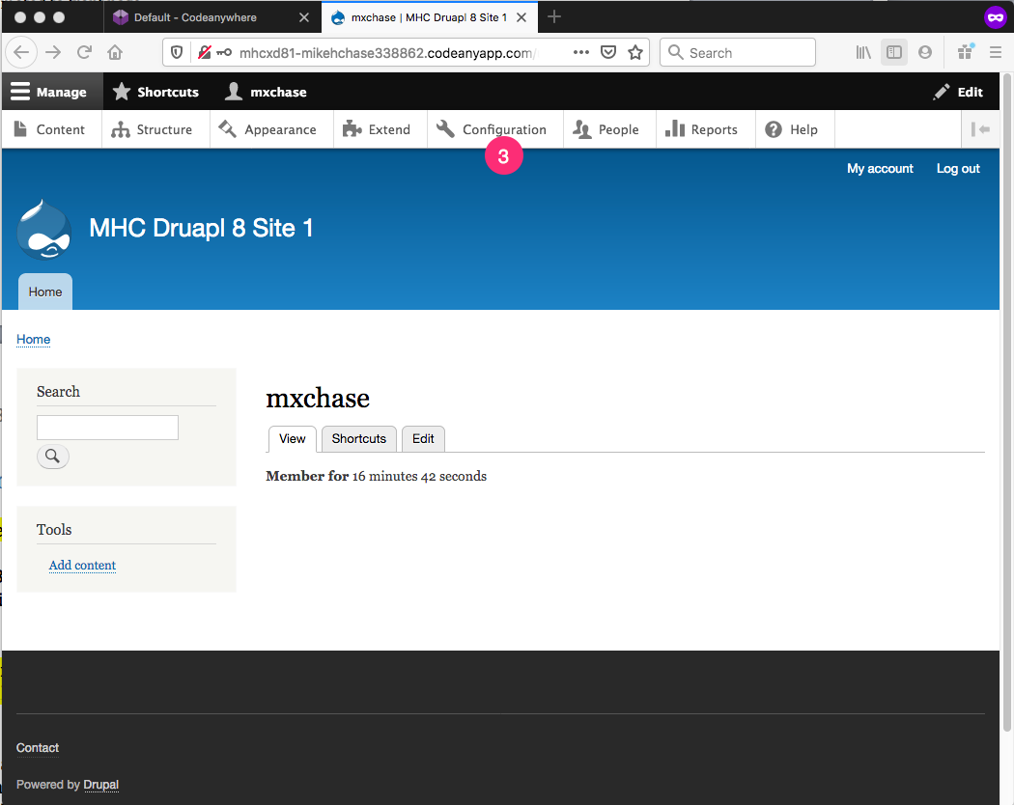

|  |
| --- |
| HD:private:var:folders:vh:lbh1qypx7zldldk1l9f6tpsc0000gn:T:2019-12-17_08-31-53.png |
| HD:private:var:folders:vh:lbh1qypx7zldldk1l9f6tpsc0000gn:T:2019-12-17_08-32-47.png |

Go to the template and take and post the requested screen captures for Part H.

**Part I – Questions or problems with this tutorial?**

Congratulations on completing this tutorial. Please submit the renamed and completed template to D2L for review and grading.

If you have questions or issues about this tutorial please contact the instructor immediately.

To get help, either submit an IRT, or make an appointment with the DePaul tutor or connect to BlueStar and make an appointment for an office hours appointment for help. **If you find errors with this tutorial, please fill out a BRECT form and submit it to the instructor ASAP for Extra Credit points.**

Michael H Chase

Mobile: 847-878-6225

Office: 312-362-1352

Email: [mchase2@cdm.depaul.edu](mailto:mchase2@cdm.depaul.edu)

Submit your completed tutorial template to D2L dropbox for the current weeks tutorial. If you prefer not to navigate by hand to the D2L dropbox, take advantage of the dropbox link in the current D2L Module Tutorial section. The D2L link will take you to the correct tutorial dropbox location.